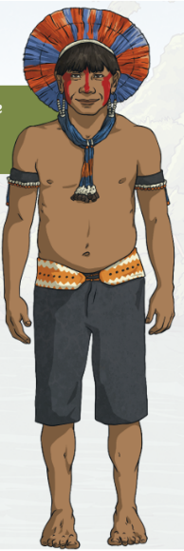
Kayapo Facts
The Kayapo Indians are one of the main Amerindian (native) groups that remain
in the rain forest around the Amazon River in Brazil.

LANGUAGE
Kayapos are divided into smaller tribes with their own chiefs, although they all
speak the Kayapo language. Some tribes can speak other languages too

Homes
The Kayapos live in thatched-roof huts without room divisions. The thatch for
the roofs is made of palm leaves. The huts are quite roomy and large enough for
an entire family. Instead of using mattresses, the bedding usually consists of hammocks. These are much cooler and more comfortable in a jungle environment.
For transport the Kayapos use canoes to travel long distances in the Amazon. They can also trek for days or weeks at a time.
FAMILY LIFE
The Kayapos live in large family groups in villages. The women harvest the family's garden for vegetables. They also prepare body paint with the help of their children. Colour dyes are created from mixed fruits and charcoal. The men hunt and fish.

CLOTHING
A Kayapo chief wears ceremonial feathers as part of his headdress. A headdress made out of bright golden-yellow feathers looks like the rays of the sun. Other ornaments include beads, cotton bands, or shells, which women also wear.
Girls and boys wear coloured cloth bands of various bright colours. These are tied and sometimes knotted below the waist or crisscrossed across the chest. They also wear ornaments such as beaded necklaces, wrist-bands, and armbands. Young Kayapos are usually barefoot. Body paint is an important addition for men, women, and children alike.

FOOD
Fish is a main source of protein in the Kayapos' diet. Wild fruits and Brazil nuts are eaten. Vegetables are harvested, and animals such as monkey and turtle are hunted. Some animals are eaten rarely except during festivals. Kayapos are skilled hunters. They use blowguns and darts dipped in a type of poison called curare, which instantly paralyzes an animal.

EDUCATION
Most Kayapos continue to teach their young people the skills necessary to survive in the rain forest. These include hunting, fishing, trekking, and making and using canoes. Growing vegetables, beading, body paint preparations, and cooking are skills Kayapo girls are expected to know.

CRAFTS AND HOBBIES
Kayapos make beautiful beaded necklaces, some a brilliant blue or yellow. They also make bracelets and earrings using shells or stones, and headdresses made from the brightly coloured feathers of various Amazon birds. The Kayapos are skilled in preparing and applying intricate designs as body paint. They weave sturdy and flexible hammocks. They also make their own canoes as well as fishing and hunting implements such as spears, clubs, blow guns, arrows, and darts.

