Year 3 Maths 01.02.21 – Bronze Challenge
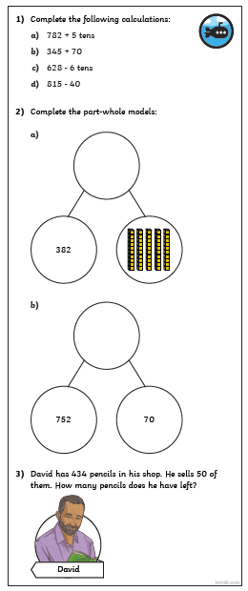
Year 3 Maths 01.02.21 – Silver Challenge

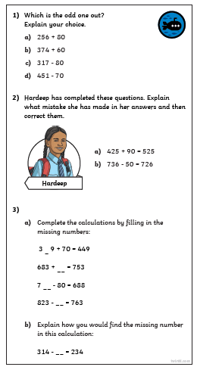

Year 3 Maths 01.02.21 – Gold Challenge

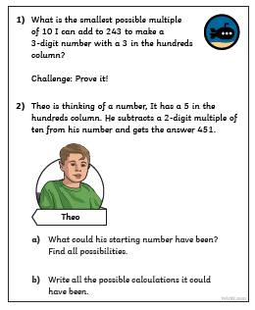

Year 3 Maths 01.02.21 – Extension

