Year 3 Maths 18.01.21 – Bronze Challenge

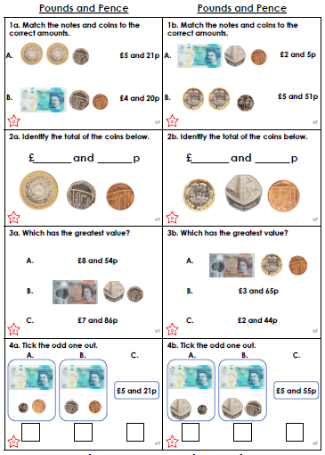
Year 3 Maths 18.01.21 – Bronze Challenge

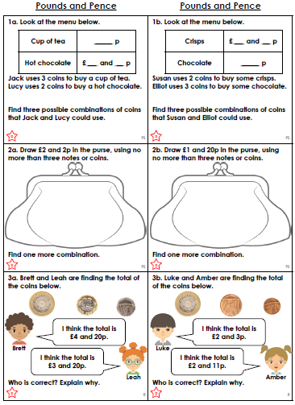
Year 3 Maths 18.01.21 – Silver Challenge

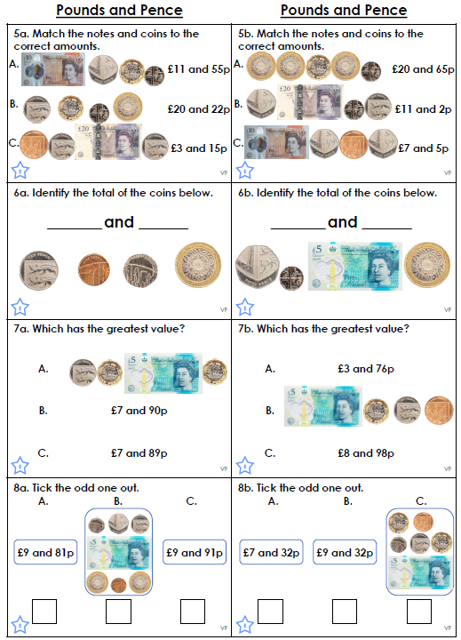
Year 3 Maths 18.01.21 – Silver Challenge

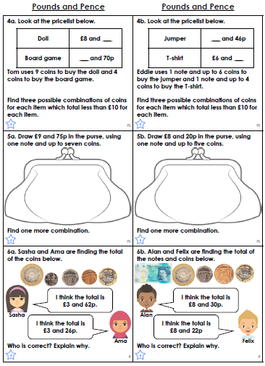
Year 3 Maths 18.01.21 – Gold Challenge

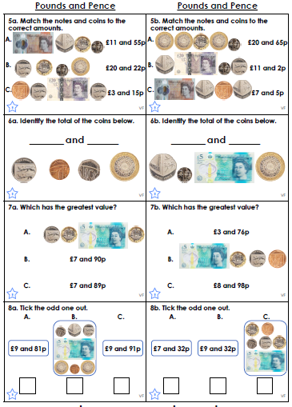
Year 3 Maths 18.01.21 – Gold Challenge

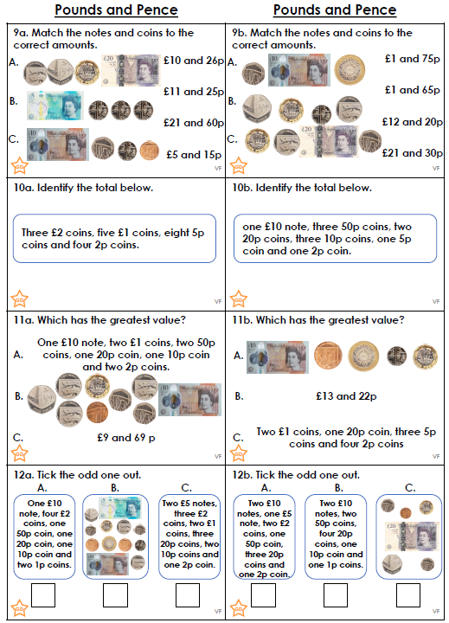
Year 3 Maths 18.01.21 – Extension

