Bronze: Can I add and subtract multiples of 10 and 100 to 3 digit numbers?

+10 -10 | +100 -100

-10 +- 10 | + 100 - 100

+ 40 - 20 | + 300 -200

Silver
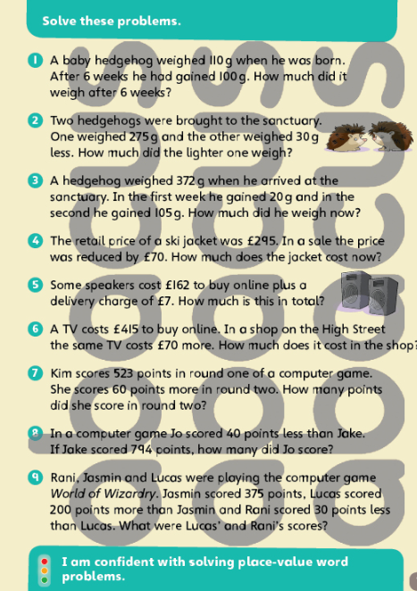

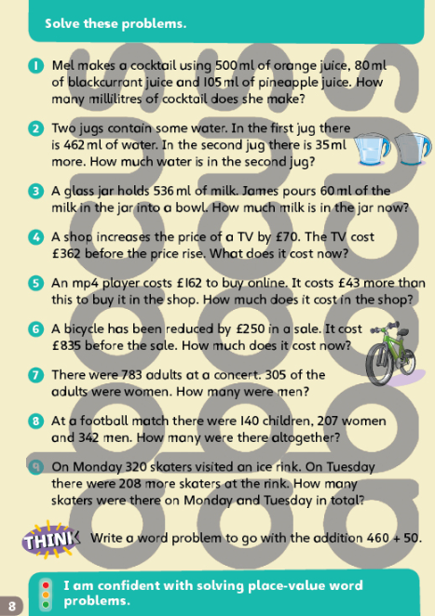
Gold

