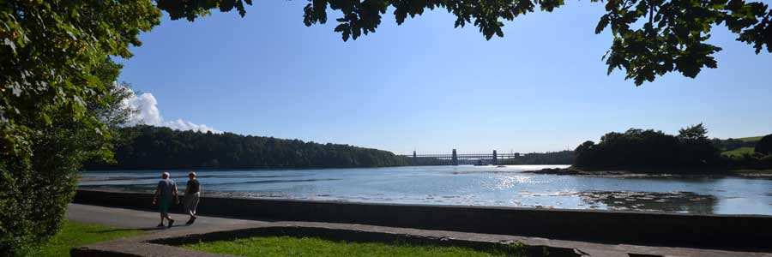
Anglesey – 125 miles of spectacular coastline

Set off the coast of North Wales, and a short drive from Liverpool or Manchester, lies the beautiful and diverse Isle of Anglesey, which boasts over 100 miles of spectacular coastline within an Area of Outstanding Natural Beauty.
The Island’s variety is its special attraction, and because of this has been a popular destination for holiday makers from across the North West for many years.
Anglesey – the largest Welsh Island
Anglesey is the largest island in Wales and has three very distinct geological areas due to a fault line which crosses the Island diagonally from west to east.
To the north of the fault line lies some of the Island’s finest natural features, remote and dramatic landscapes. The centre of the Island is very low lying and contains some of Anglesey’s most ecologically important habitats including National Nature Reserves.
The southern part of the Island boasts the most diverse landscapes including limestone escarpments and cliffs off the eastern point around Penmon and the rolling woodlands and dune complex of the Newborough National Nature Reserve on the Island’s south west tip.
The whole area is noted for its archaeological interest and sites include the splendid medieval castle at Beaumaris, remains of native Welsh palaces and numerous prehistoric standing stones and burial chambers due to a rich history passed on from its Celtic, Viking and Medieval settlers.
Naturally the island is a haven for watersports enthusiasts, but it is also popular with those seeking either a relaxing or a non-water based action break. The island offers something for everyone and whatever time of year you visit, you will be spoilt for choice!

