Isle of Lewis
The largest island of the Outer Hebrides, Lewis offers amazing opportunities to explore all the elements life on the edge in the Atlantic Ocean – with history, heritage, wilderness, wildlife, arts, crafts, crofting culture and even adrenaline fuelled adventure all here for the taking on your Hebridean holiday.
From the neat Victorian homes lining the streets of Stornoway in the east, to the stretching white sands of Bosta on Great Bernera in the east, where the clear Atlantic waters sound the evocative toll of the Time and Tide Bell as a reminder of the link between us and the elements, Lewis is an island of exciting contrasts and diverse experiences.
Discover the rich history of the proud Lewis people, from the Norse invasions to the strong Gaelic traditions that are still observed today. Head to Ness, a stronghold of the local language, and listen to the sound of Hebridean heritage being carried on the winds which rage around this northern headland making it the windiest spot in the UK.
Learn how the islanders enduring struggles against both the elements and authorities led to many leaving the land they love at the Ravenspoint Centre in Lochs – home to the Patagonia collection commemorating reluctant emigration from the area.
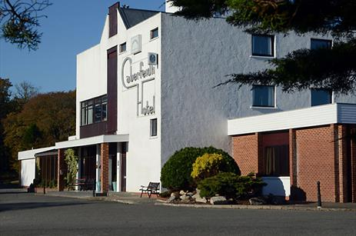

Cabarfeidh Hotel
A 4-star luxury hotel, the informal Cabarfeidh offers modern guest rooms with bath and shower, large beds, free wi-fi and flat screen TV....
Taste the true spirit of the islands at the Uig Districts Abhainn Dearg Distillery – the only legal producer of scotch whisky in the islands where workers follow time honoured traditions to produce this well-loved “water of life “or head to the nearby Ardroil sands for an extreme kite- or windsurfing experience.
See the ancient Callanish Standing Stones rising from the Lewis landscape to give an imposing outline against the endless island skies and hear the echoes of the past murmuring round these monoliths – an eternal testament to islanders enduring spirit and ingenuity.
Explore the sea caves and stacks at Garry Beach just round the headland from Broad Bay to better understand how the relentless seas have shaped this island environment, and the lifestyles of those who live here.
Whatever you are looking for, you can find it here on Lewis, along with a warm Hebridean welcome.

