Welcome to Isle of Skye
The Isle of Skye is the largest of the Inner Hebridean islands. It stretches for fifty miles from Rubha Hunish in the north, to the Point of Sleat in the south and is more or less the same distance east to west: yet it is impossible to travel farther than five miles from the sea due to the number of sea lochs which penetrate deep into the heart of the island. But Skye is not considered amongst the most romantic of islands solely because of its long broken coastline: the Black Cuillin mountains' jagged peaks have inspired awe in those arriving from the south for thousands of years; on the Trotternish Peninsula, in the north, The Quirang, with its towering pinnacles, is one of the most distinctive mountainscapes in the world; just south The Old Man of Storr stands solitary, a 165 feet high needle of rock, which no man summoned the courage to climb until 1955; meanwhile, wild and erratic weather creates the illusion of the island as a living, breathing creature, that sleeps in mist and roars in the wind.

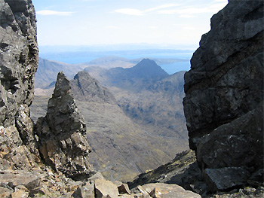
View from The Quirang, Isle of Skye

Mesolithic man arrived in Scotland around 6000 BC. These hunter gatherers were largely nomadic, travelling along the coast and dependant largely on fishing. The earliest remains of man to have been found in Scotland were discovered on the neighbouring island of Rum, around five miles off Skye's south eastern coast. Although as yet no such remains have been found on Skye, all available evidence suggests that these early inhabitants operated comfortably within Scotland's sea world, of which Skye is a major, and surely unavoidable, part. Two thousand years after the hunter gatherers had arrived, cereal cultivation came to provide the basis for the development of a more stable economy and sophisticated civilisation. In this period we begin to see the appearance of stone circles and chambered burial cairns. Examples of Neolithic architecture can been seen all over Skye; The High Stone of Uig, Clachan Erisco, and Na Clachan Bhreige, are just some examples of stone circles, while burial cairns include Kilmarie, Rudh' an Dunain, Kensaleyre and Liveras.
The emergence of this architecture underlies a culture whose settlements had become permanent which implies the growth of territorialism which, in turn, implies territorial dispute. Growing tension is evidenced by the abundance of swords, spears and stone axe heads which begin to appear between 2000 and 1000 BC (such artefacts have been unearthed in Ach-na-Cloich, Hulabost, Roskill, amongst other sites). In the 1st millennium BC we begin to see the development of hill forts, or ‘duns', such as the remains at Dun Beag, Dun Cruinn, Dun na h-Airde and Dun Grugaig. Around the same time the ‘broch', a circular tower with three metre thick walls, came into being. There are many remains of brochs on Skye: amongst the best preserved are Dun Fiadhart, Dun Osdale, and Dun Ringall.

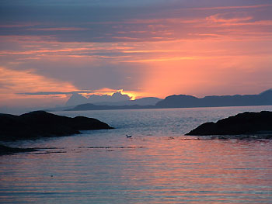
Isle of Skye Sunset

The first recorded Viking attack on Skye took place in 794 AD. 875 AD saw the arrival of Norwegian settlers on the island; by 907 intermarriage had made the islanders a Celtic-Norwegian mix. In 1098, in retaliation for the killing of a Norse viceroy, the kings of Norway invaded the Western Isles and set up the Kingdom of Man and the Isles, under Olave the Red, whose capital was the Isle of Man. Scottish kings never accepted the territory as Norwegian and constantly strove to incorporate it into their realm, which they finally did in 1266, in the aftermath of the Scots victory over the Norse army of King Haakon in the Battle of Largs.
Nonetheless, the degree of independence which the Western Isles enjoyed as a sub-state in the Norwegian empire had created an independently minded people who would not be easily dominated by the Scottish crown. Skye was divided among a number of clans, most notably the MacDonalds and McLeods, who were to spend the following centuries competing for power. Although initially part of the Earldom of Ross, the MacDonalds eventually gained the upper hand in the power struggle when Skye fell under the control of the Lords of the Isles, simultaneously the chieftains of the MacDonalds. They ruled the western seaboard much as their Norse predecessors had: using a kind of galley derived from that of the Vikings for transport, communication and warfare. The Lords of the Isles fiercely defended their empire against the crown until 1462 when John MacDonald, accused of treason, forfeited the lands to King James IV.
The loyalty founded in 1462 for the house of Stewart, of which James IV had been a member, would cost the people of Skye dearly. When the dynasty was supplanted by that of William of Orange an uprising began in the Highlands and Islands and Skye's people were amongst those to rebel. The uprising came to a bloody end in 1746 at the Battle of Culloden and Prince Charles Edward Stewart (Bonnie Prince Charlie) went into hiding in the islands. On South Uist he came across Flora MacDonald, who offered to row the Prince, disguised as an Irish farm girl, over to Skye to aid him in his escape; assistance she later paid for with a year in the Tower of London. This tale became legend and has linked forever the Jacobite cause and the Isle of Skye in the popular imagination. Flora MacDonald's crossing in her boat is also seen as one of the last images from an old Gaelic sea world before it was swept away, being at the forefront of government persecution which sought to destroy the culture which had played host to its enemies.

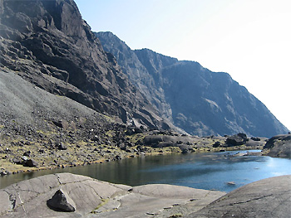
The Cuillins, Isle of Skye

The clan system, already in upheaval due to the conflict, was attacked: Gaels were not permitted to carry weapons, wear tartan or play the bagpipes; clan chieftains which had supported the rebellion were uprooted, imprisoned and killed. The clan chiefs who remained unscathed emerged as ruthless landlords; even before the end of the conflict chiefs, including those of the MacLeods and MacDonalds, participated in the kidnapping of their people to be sold into slavery in the Carolinas. The new landlords, motivated by profit, never ceased to devise new ways of forcing their tenants out of their ancestral lands, to be replaced by sheep, which were seen as more profitable. Immigration from Skye began after the failure of the rebellions but reached its height between 1840 and 1880, in what have gone down in history as ‘The Clearances' when somewhere between 20,000 and 30,000 people were driven from the island. Tenants were forcibly evicted by landlords, who had their homes burnt with the full support of the law. The expression ‘to be fired' is said to owe its origin to this practice: as crofters houses were burnt they were simultaneously put out of work.
The practice only ended following public outcry at the treatment of Crofters during the 1882 uprising: the ‘Battle of the Braes' in which Crofters took on the landlords' lackeys and the police in a pitched battle. Some historians regard The Clearances as an emotive but minor event in the depopulation of the Highlands and Islands, which, they claim, was primarily the result of crop failure and famine. Certainly famine drove many away from islands such as Skye. However, the wonton disregard shown by successive governments for the sufferings of the islanders is perhaps more accurately seen as symptomatic of a deliberate policy towards Gaelic speaking Scotland, of which The Clearances has become the most emotive symbol. In effect, the policy amounted to nothing short of ethnic cleansing.
Skye has emerged from this turbulent and tragic history due to the success of fishing and tourism. Such a past has bequeathed Skye with an almost unparalleled number of sites of interest: from prehistoric remains, through medieval castles and churches, to abandoned crofts and townships, and picturesque towns. The backdrop is the majestic, emblematic mountains and the soundtrack: the ceaseless crashing of the waves. No Scottish island offers more than Skye in terms of natural beauty; here more emotive, perhaps, due to the melancholy that, owing to the island's past, emanates from the awe inspiring vistas with which one is confronted at every turn. See also: Isle of Skye Attractions

