Monday 25th January - Geography

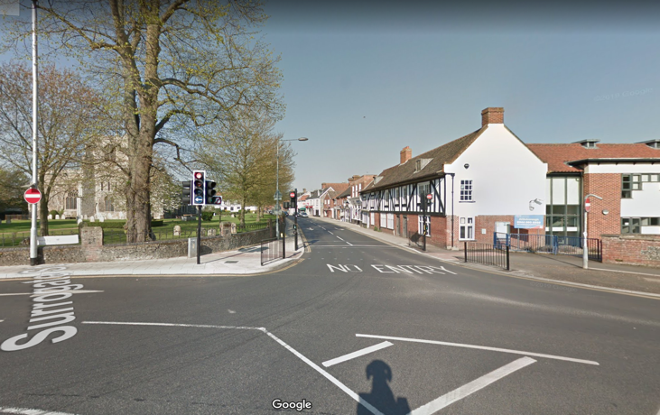
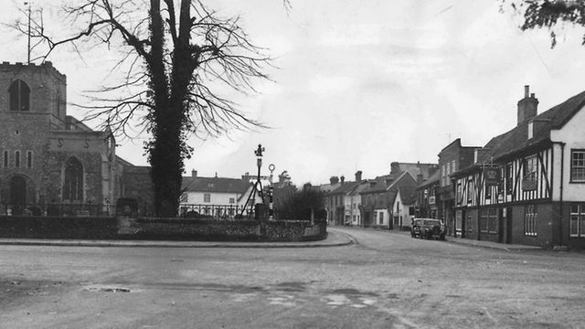
Below are two comparative pictures of the same place in Attleborough. The pictures on the left (in black and white) were both taken in the 1950s. The colour pictures on the right are from the latest Google Maps from 2019.

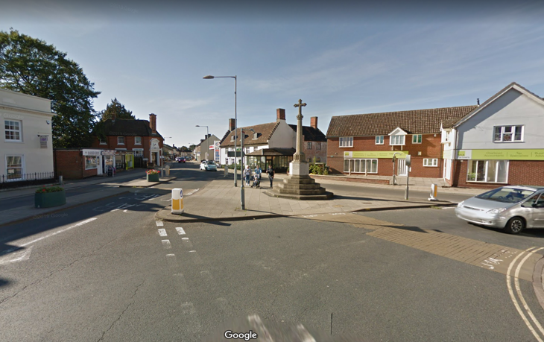
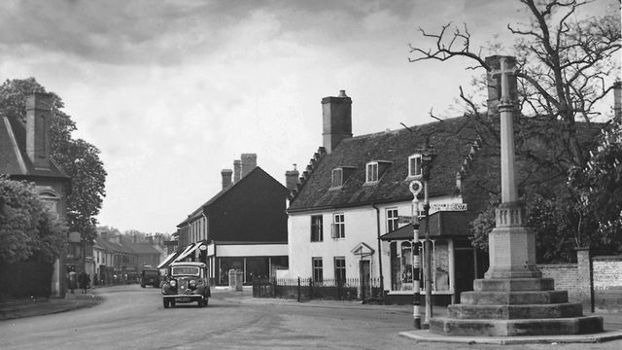
Below here are two birds-eye views of Attleborough – the one on the left from 1988 and the one on the right is from 2020.
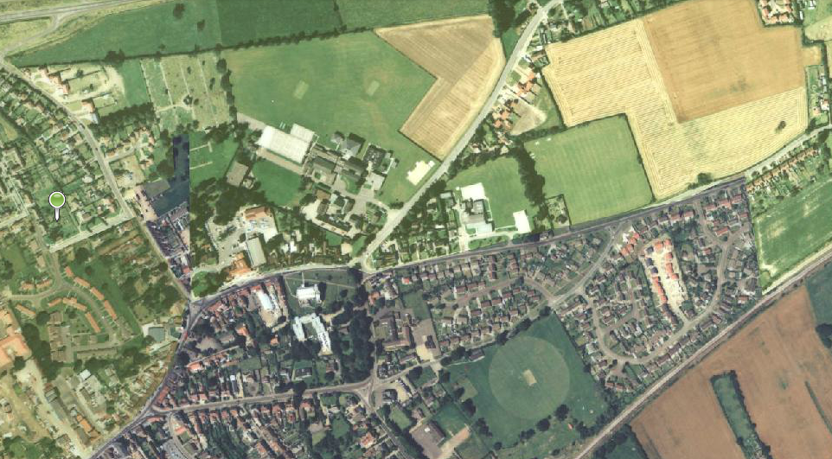
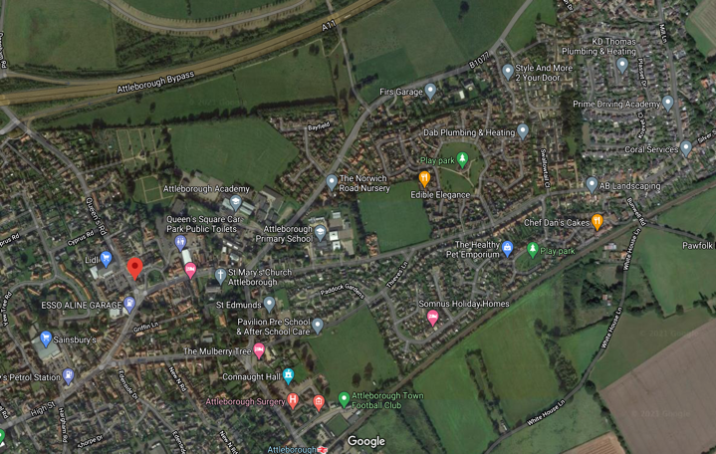

Bronze, Silver and Gold:

What do you notice about how Attleborough has changed? Use the pictures to help you.

Why do you think Attleborough has had to change?

Silver and Gold:
Do you think Attleborough has changed for the better? Explain why. (Think about what you can see in the pictures, especially the 1988-2020 map).

