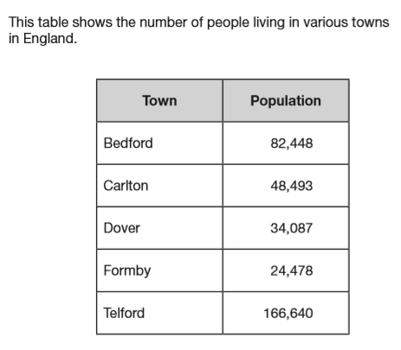
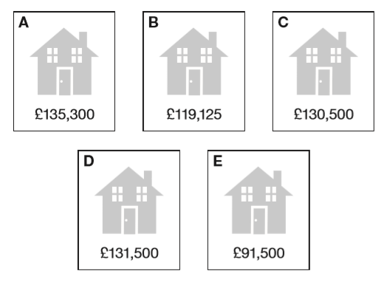
Use the information boxes below for the task.
Choose an image and answer the questions:
What do you see? What do you notice? What do you wonder?

THEN use the information to tell me something mathematical and the calculation you would use to tell me that something.

Bronze: One calculation Silver: Different types of calculations
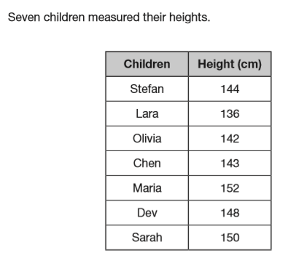
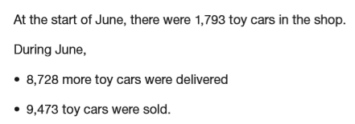
Gold: Information which requires more than one step.

