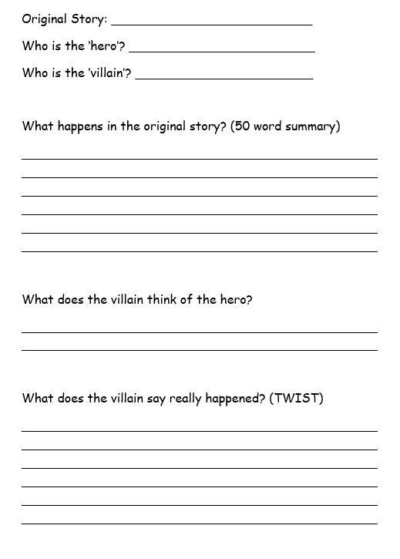
BRONZE, SILVER AND GOLD: Think about the fairy tale you would like to twist. Complete the sheet, thinking carefully about your narrator (the villain who is trying to make us feel sorry for them!)

