Tuesday RE – Buddhism, Hinduism and Sikhism

Buddhism

For Buddhists, what they are reborn as depends on their actions in their previous life.

Emancipation is a word meaning freedom. Buddhists believe that emancipation from the cycle of birth, death and reincarnation is considered to be the ultimate goal of Buddhism, as well as Sikhism and Hinduism. This goal is called Nirvana.

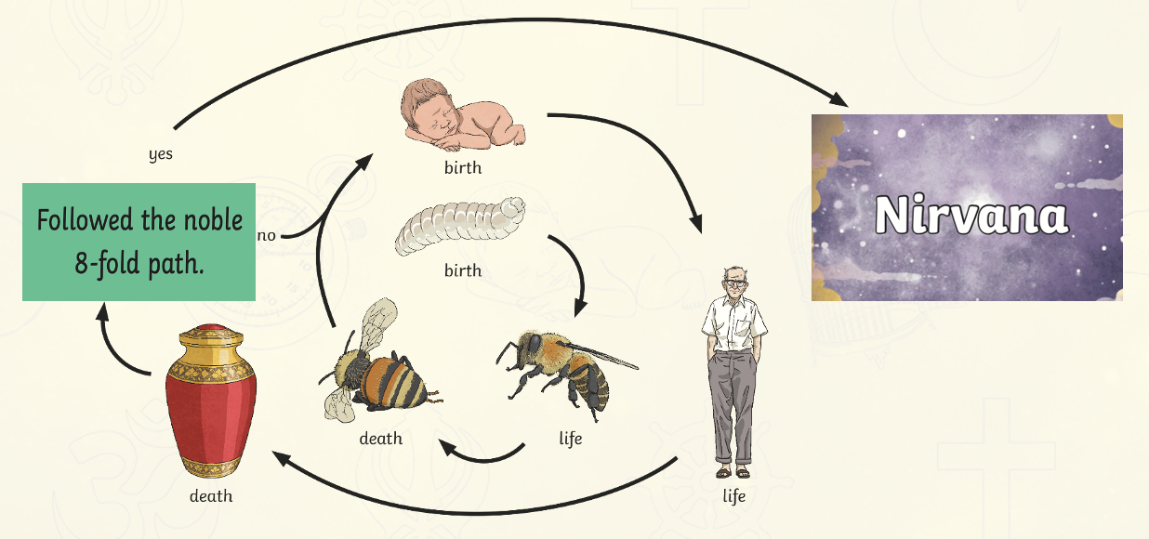
Nirvana is not a place, but an actual state of non-existence. Buddhists do not believe in god, but instead try to reach this state of nirvana – a word that means to extinguish or blow out. When someone reaches nirvana, there soul is in harmony and at peace with the universe. This means they would cease to exist.

Hinduism

Hindus also believe in the concept of reincarnation. Hindus believe that the cycle can continue for thousands of lifetimes.

Like Buddhists, Hindus also believe in karma. They say that if you are kind and considerate, you will have good karma; however, if you are selfish, you will have bad karma. This affects how they will live in the next life.

However, unlike Buddhists, Hindus do believe in a god. Hindus worship a supreme God, called Brahma, who can take on many forms. In Hinduism, Brahma was the creator of the universe.

The ultimate aim of Hinduism is to leave the cycle of rebirth. This will allow them to become one with the god Brahma. This is called Moksha.

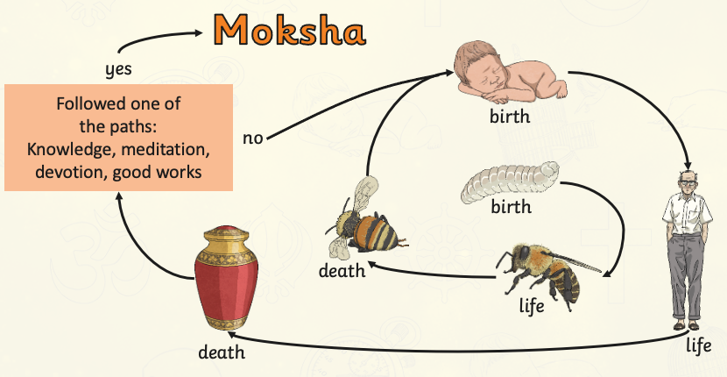

Sikhism

Like Buddhists and Hindus, Sikhs also believe in the concept of reincarnation. Sikhs believe that there are over 8 million different life forms they may experience before they are free from the cycle of reincarnation.

And much like Buddhists and Hindus, Sikhs also believe in karma – that your actions affect your next life form. Sikhs believe that people who are reborn as an animal have achieved bad karma, and are further away from being free of the cycle.

Similarly to Hindus, Sikhs also believe in a God. However, Sikhs believe that God does not have any particular form.

The ultimate goal for Sikhs is to achieve Mukti, meaning liberation. In order to reach Mukti, Sikhs must rid themselves of all bad karma and focus on good karma. Mukti involves being one with god. Therefore, when they achieve Mukti, they will be free of the cycle and at one with God.

