The Eightfold Path
What is the Eightfold Path?
The Eightfold Path consists of eight areas of life that people focus on towards the path of Buddhism. They can be worked on in any order and some are more difficult to achieve than others depending on the situation or the person. It is designed to relieve suffering.
Buddhism works on promoting learning and self discovery rather than ‘blind faith’. Blind faith is when a person accepts something without really thinking it through for themselves.
Right Understanding
Having right understanding is when you see the world as it really is and not how you want it to be. Sometimes we try to change things that are outside of our control and we can get upset or not understand things clearly.
Right Intent
Right Intent means we can commit to a decision or action for the right reasons, once we understand things properly by looking at what is really there and not what we want it to be like. We need to ask ourselves if we are just being selfish, or are we thinking of others with care and compassion?
Right Speech
Often things we say in anger or gossip behind people’s backs can cause upset and hurt, and take
a long time to sort out. Having Right Speech is deciding never to speak unkindly or in anger.
Right Action
Right action means behaving in a thoughtful way, considering others and the world we live in. Through our actions, it is a chance to keep the world safe for future generations to live in.
Right Livelihood
Our livelihood, how we choose to work and earn money, can have an effect on the world at large. Buddhists do not agree that people should work in a job that might cause harm to others. They would not agree with being a gun seller, butcher or any job that involved harming animals. They believe that we should work for the good of the community and benefit the world as a whole.

Right Effort
Sometimes we put a lot of effort into the wrong things. Like wanting to be the best, the prettiest or the wealthiest. Right Effort is concerned with developing a positive attitude and cheerful determination in a balanced way. This involves putting effort in to avoid feelings like greed and jealousy, and the right effort into developing feelings of compassion and consideration of others.
Right Mindfulness
Sometimes we are caught in a moment that takes our breath away, or we get so completely focused on something, we do not notice what is going on around us.
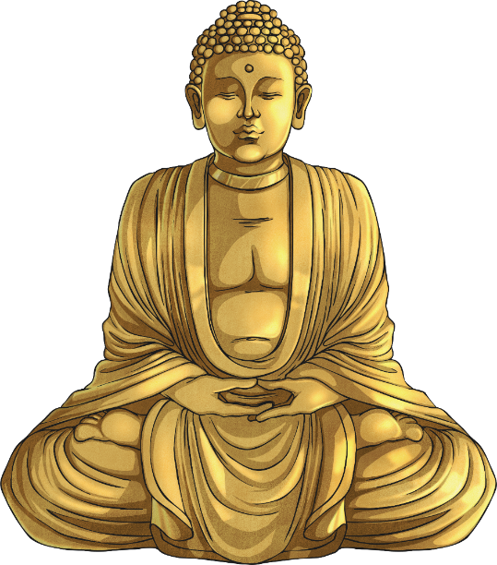
This is an awareness of a moment and our actions in that moment. We suddenly notice old habits that have controlled us and can focus on changing ourselves.
Right Concentration
Concentrating is sometimes hard because we allow ourselves to get distracted. The Eightfold Path step of Right Concentration encourages us to focus the mind on something so completely, we see it as it really is and not how we have always thought it is, or been told to see it. This action frees us from being controlled and leads us towards freedom.

