Is there more than one solution? Why?

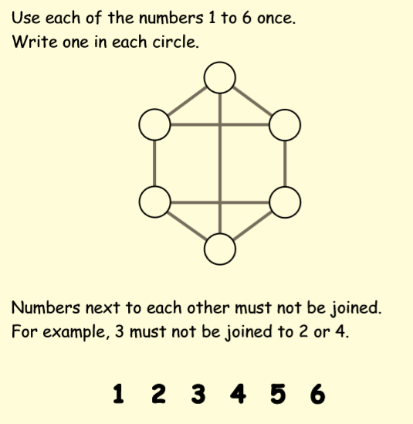

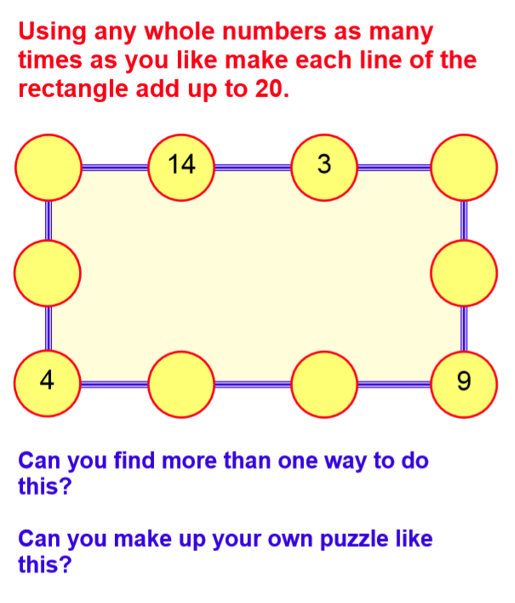

Write any other solutions here:

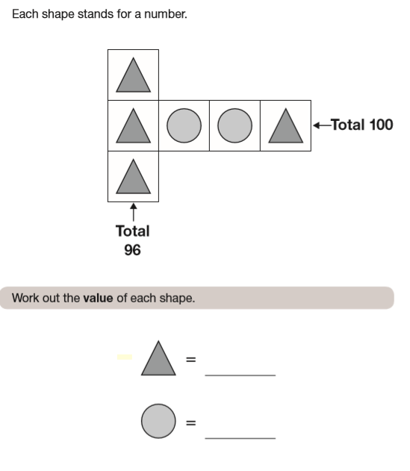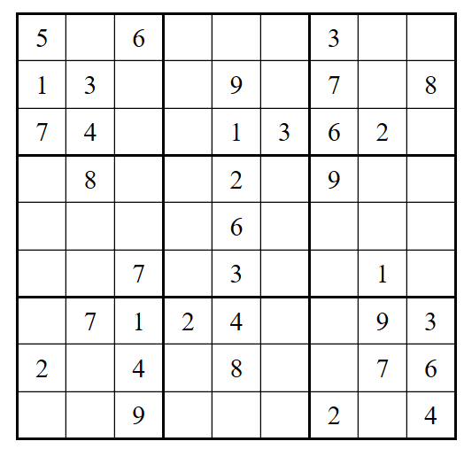

Write any working here:

In a Sudoku puzzle, you must use the digits 1 to 9 only. Each row and each column must contain the numbers 1 to 9 and each 3x3 box must also contain the digits 1-9.

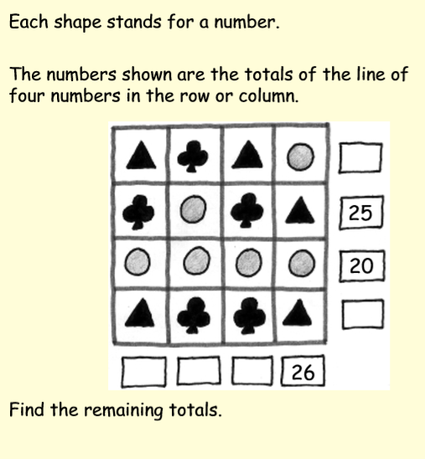

What if a circle’s value increases by 2?

What will change, what will stay the same?