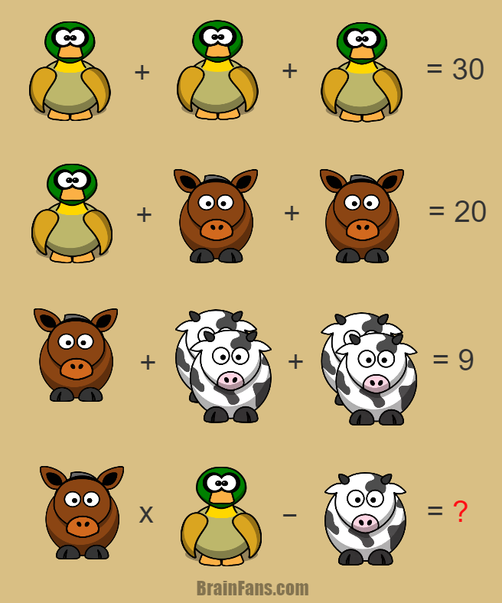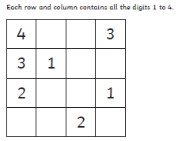

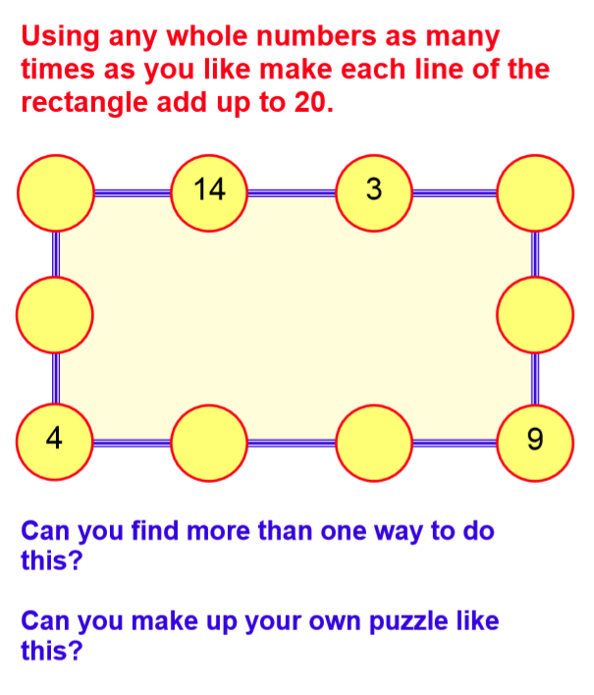

Write any other solutions here:

In a Sudoku puzzle, you must use the digits 1 to 6 only. Each row and each column must contain the numbers 1 to 6 and each 3x2 box must also contain the digits 1-6.

