Colons activities

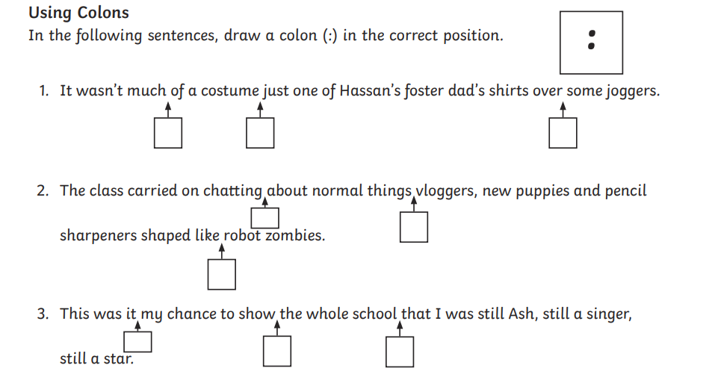
Bronze:

Now write two sentences of your own using colons:

………………………………………………………………………………………………………………………………………………….
………………………………………………………………………………………………………………………………………………….
………………………………………………………………………………………………………………………………………………….
………………………………………………………………………………………………………………………………………………….
………………………………………………………………………………………………………………………………………………….
………………………………………………………………………………………………………………………………………………….

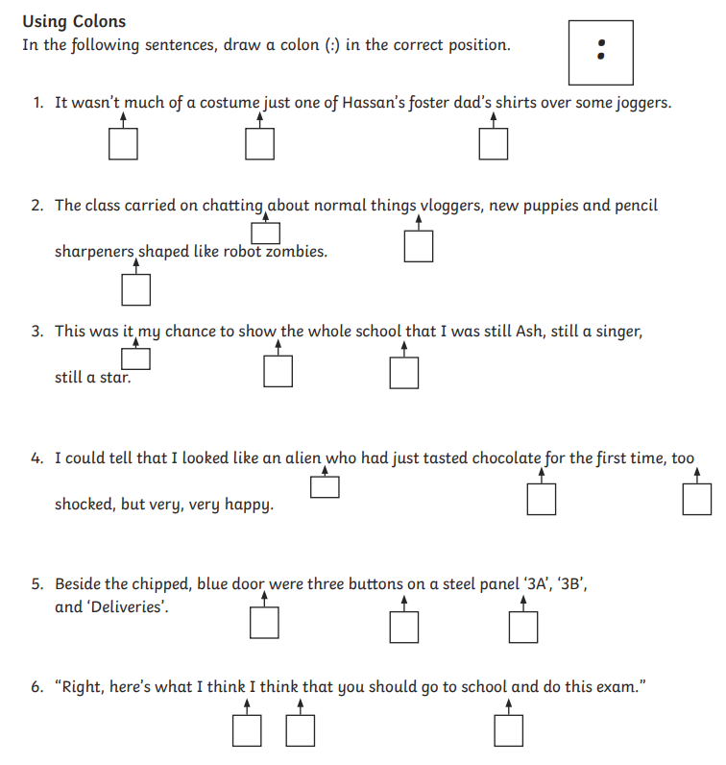
Silver:
Now write two sentences of your own using colons – try to use them in different ways:
………………………………………………………………………………………………………………………………………………….
………………………………………………………………………………………………………………………………………………….
………………………………………………………………………………………………………………………………………………….
………………………………………………………………………………………………………………………………………………….
………………………………………………………………………………………………………………………………………………….
………………………………………………………………………………………………………………………………………………….

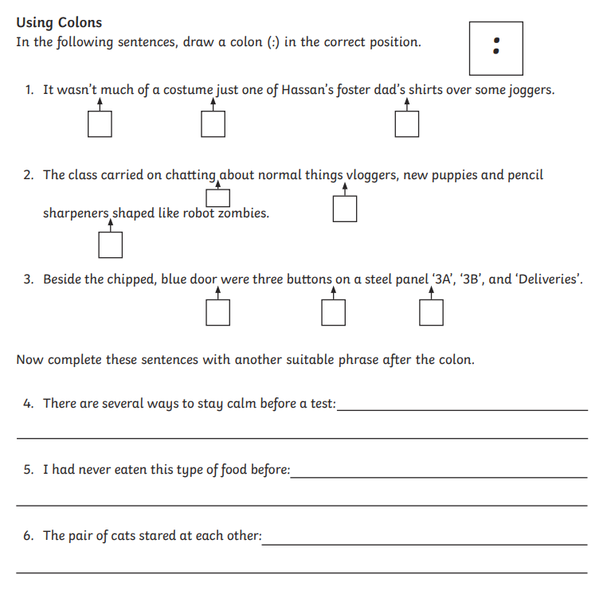
Gold:
Now write two sentences of your own using colons – try to use them in different ways. Ensure that you have used ambitious vocabulary in each sentence:
………………………………………………………………………………………………………………………………………………….
………………………………………………………………………………………………………………………………………………….
………………………………………………………………………………………………………………………………………………….
………………………………………………………………………………………………………………………………………………….
………………………………………………………………………………………………………………………………………………….
………………………………………………………………………………………………………………………………………………….

