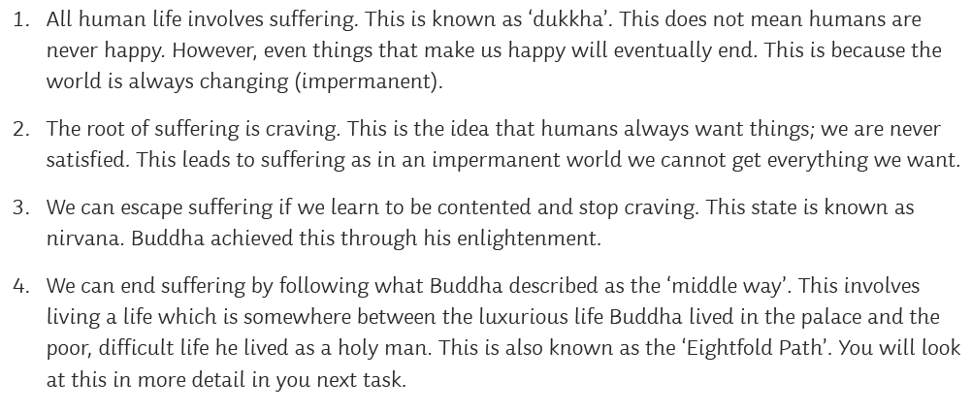
Notes on the four noble truths in Buddhism

Use these to create a poster to demonstrate each noble truth.

